CAD PRACTICAL TASK

Submission Details – Travel Website with AI Chatbot Integration
Name: Neemay Gupta
Roll No: 11024210004
Email: neemay.gupta2007@gmail.com
Section: 4A
Live Bot Link (Deployed on Vercel):
https://wander-lust-sigma-five.vercel.app/

GitHub Repository Link:
https://github.com/Neemayg/WanderLust

WhatsApp Integration:

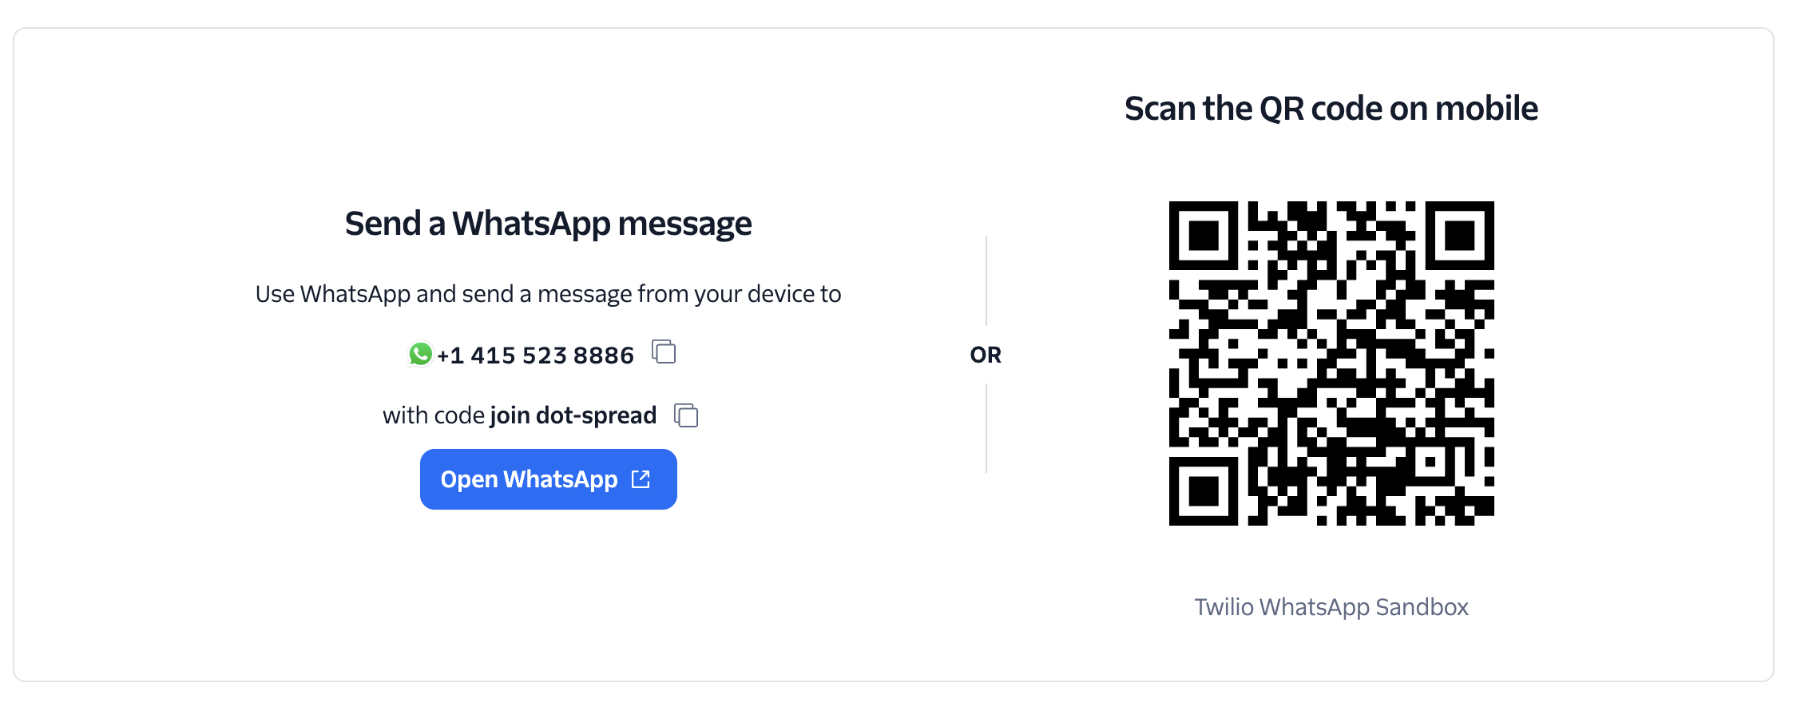

Project Description
WanderLust is an interactive travel website integrated with an AI-powered chatbot designed to assist users in exploring travel destinations and obtaining useful travel information. The platform provides an engaging interface where users can discover destinations, gather travel insights, and receive recommendations through an intelligent chatbot assistant.
The project has been successfully deployed using Vercel, making the website publicly accessible through the live link provided above. The complete implementation, including the website interface and chatbot integration, is available in the GitHub repository for review and reference.

